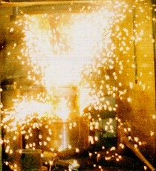

**Obtaining products from tungsten-free**

**hard alloys using the SHS method with compaction**

**A.A. Filippenkov, V.G. Tsikarev, A.V. Alabushev**

**LLC "SVS-Composite" (RF, Ekaterinburg)**

Self-propagating high-temperature synthesis (SHS) as a method for synthesizing refractory compounds was invented in 1967 by Russian scientists Academician Merzhanov A.G. and Professors Borovinskaya I.P. and Shkiro V.M. in the academic town of Chernogolovka near Moscow while studying gasless combustion of mixtures of metal and non-metal powders [1-2].

To date, about 100 specific varieties of SHS technology have been created, which have made it possible to synthesize over a thousand substances and materials and apply SHS technologies to obtain functional powders, porous products, cast products, for applying coatings, for welding parts, etc. [3-5].

SHS materials and technologies are widely used: in mechanical engineering (abrasive, blade and stamp tools, high-temperature and wear-resistant parts), in metallurgy (ferroalloys, refractories, surfacing, electrodes, metal pipelines), electrical engineering and electronics (ferrites, ferroelectrics, insulators, heating elements, high-temperature superconductors), chemical industry (catalysts).

In this area, the Institute of Structural Macrokinetics and Problems of Materials Science of the Russian Academy of Sciences (ISMAN) - p. Chernogolovka, Moscow Region - has made great achievements. ISMAN has developed more than 20 tungsten-free grades of hard alloys for tool and structural purposes of the STIM group.

The solid basis of such alloys are synthesized titanium carbides, including additives of synthesized titanium borides and nitrides, chromium carbides, and diamond additives. The amount of the solid components specified in the alloys is 70-95%. Nickel (10-30%), cobalt (6-12%, copper (5-10%), and steel 20-30% were used as a binder in the appropriate amount.

The main result of these developments is that the resulting materials provide a combination of such properties as high strength, hardness, wear resistance, resistance to oxidation and thermal shock, which determines the feasibility of developing work on the direct production of products for units and devices of modern technology using SHS technology with force compaction.

OOO "SHS-Composite" has chosen the direction of manufacturing tungsten-free hard alloys by SHS synthesis of titanium carbide with obtaining titanium-nickel or titanium-copper intermetallic compounds as a binder, followed by force compaction of the SHS reaction products to form blanks of drawing tools.

It is known that in the titanium-nickel system - see Fig. 1, the formation of intermetallic compounds TiNi, Ti **2**Ni, TiNi **3** with melting temperatures in the range of 984-1380 **0** C takes place, which is lower than the melting temperature of nickel (1455 **0** C) and this is a technologically positive factor.

On the other hand, these intermetallic compounds, according to available data, have higher physical and mechanical characteristics than nickel, which gives reason to expect an improvement in th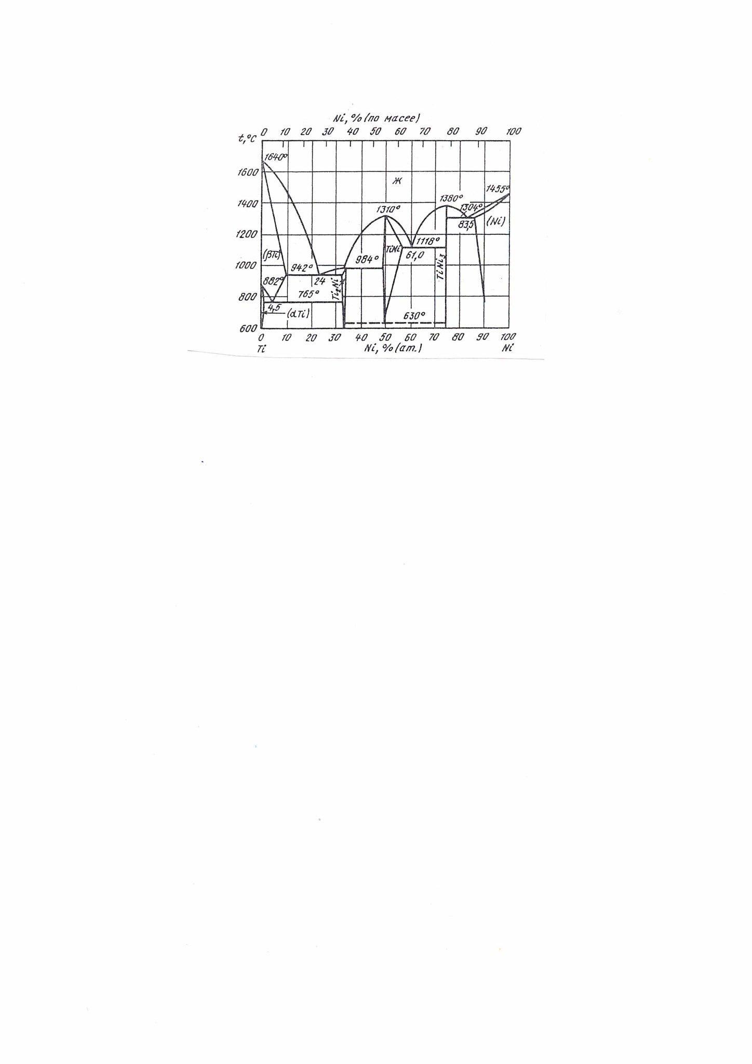e characteristics of the final product.

Fig. 1 Titanium-nickel phase diagram [6].

The presence of titanium-copper intermetallics (titanium cuprides) is also characteristic of the phase diagram of the binary titanium-copper system - see Fig. 2. The most stable titanium cuprides in this system are Ti **2**Cu, TiCu, Ti **2**Cu**3** , TiCu**3** . These titanium cuprides have melting points in the range of 885-910 **0** C, i.e. lower than that of copper - 1085 **0** C, which also has its technological advantages. There is evidence that the hardness of these titanium cuprides is 4500-6000 MPа (45-55 HRC) [ 8 ], while the maximum hardness of copper is 1100 MPa. It has also been shown that the relative wear resistance of titanium cuprides such as Cu**4**Ti**3**, CuTi is 1.6–2.4 times higher than, for example, steel 40 (HRC 49–53).

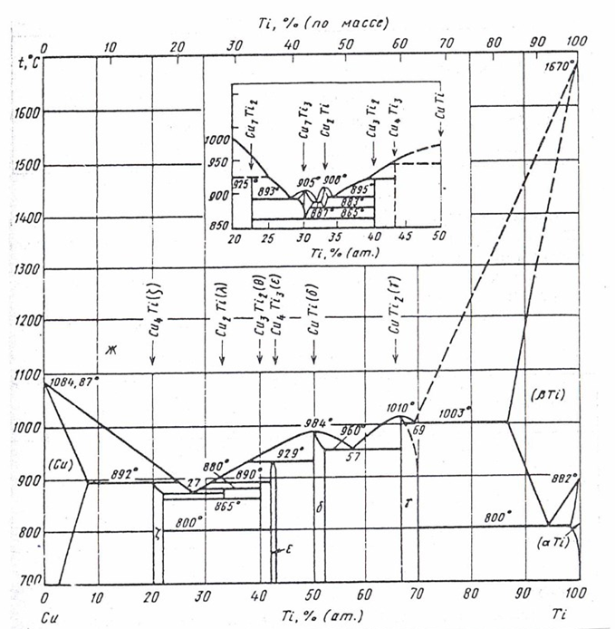

Fig. 7. На англ. Titanium-cooper phase diagram [7].

Based on the above assumptions, the composition of the SHS-charges was formed according to a specially created calculation algorithm, when the ratio of the components ensured the production of 50-65% (weight) of titanium carbide in the finished product, and the rest was titanium-nickel or titanium-copper intermetallics.

The following raw materials were used in the SHS processes:

- titanium powder produced by VSMPO-AVISMA, grade TP-7, TP-8;

- nickel powder grade H 3;

- copper powder produced by Uralelectromed, grade PMS-1;

- carbon black grades P-803, P-804, T-900.

The production of pilot blanks of the drawing tool was carried out

on a specially created pilot industrial site.

**Basic process flow chart for obtaining finished products**

Titanium powder. Nickel (or copper) powder. Soot.

↓

Mixing the initial mixture

↓

Compacting the powder mixture in the SHS reactor

↓

Initiating the reaction with a special electrode

↓

Passing the SHS reaction

↓

Pressing the obtained SHS products in a hot state

↓

Cooling the workpiece in sand

↓

Processing the workpiece to the required dimensions - sandblasting, grinding, electrical discharge machining, finishing with a diamond wheel

According to this scheme, finished products were obtained - blanks of dies with dimensions agreed with potential consumers.

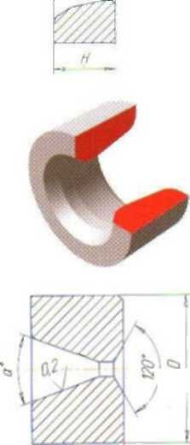 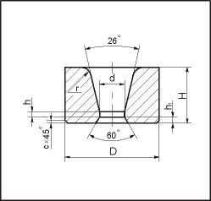

Dimensions, mm

|  |  |  |
| --- | --- | --- |
| D | Angle degrees a | H |
| 70 | 18-26 | 40-50 |
| 100 | 18-26 | 40-60 |
| 120 | 18-26 | 40-50 |

The natural appearance of the products is shown in Fig. 3 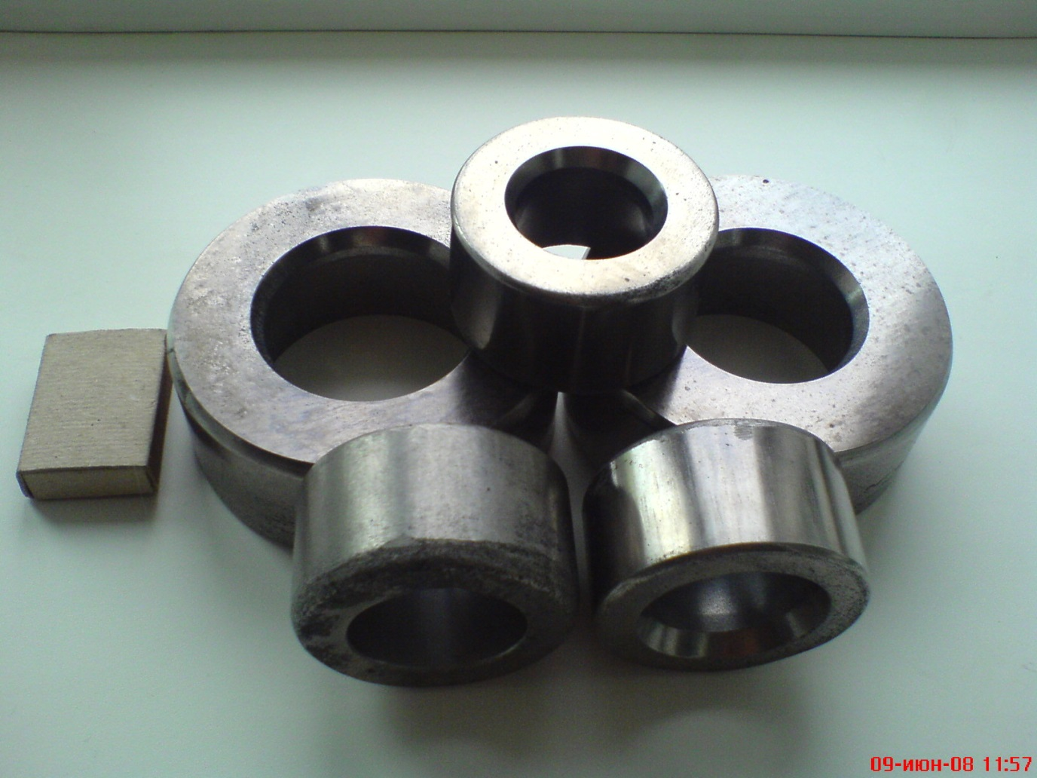

**Fig. 3 Natural appearance of finished blanks of dies**

When studying the phase composition of the obtained alloys, the presence of titanium carbide (TiC) as a base (50-65%) with the presence of no more than 2% of non-stoichiometric titanium carbide was revealed. The rest is various combinations of intermetallic compounds: in the Ti-Ni-C system these are TiNi, Ti**2**Ni, TiNi**3** , and in the Ti-Cu-C system, respectively, Ti**2**Cu, TiCu, Ti**2**Cu**3** , TiCu**3** with the presence of no more than 1% of pure nickel or copper. This fact confirms the technological feasibility of implementing our idea. The hardness of the product material is: with titanium-nickel intermetallic compounds 68-70 HRC (85.5-86.5 HRA), with titanium-copper intermetallic compounds 62-64 HRC (82.5-83.5 HRA). Wear resistance tests of these two types of alloys using the abrasion method in comparison with standards (metals) of similar hardness showed a twofold increase in the wear resistance of the resulting alloys based on titanium carbide with bonds of titanium-nickel or titanium-copper intermetallics.

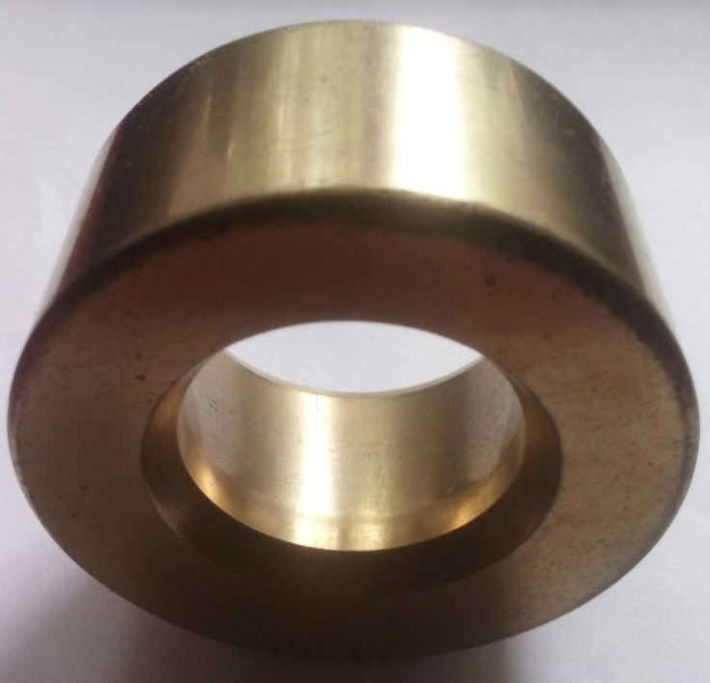

Рисунок 4. Titanium nitride coated die blank

The composition of the charge and the SHS technology for producing a tungsten-free hard alloy with a titanium cupride binder were granted Russian Federation Patent No. 2691656 with priority dated 22.01.2018.

The pilot blanks of the dies obtained at the existing pilot industrial site are being tested: products with nickel - when drawing pipes at specialized enterprises in the Ural region, and products with copper - at Ural plants for the processing of non-ferrous metals in relation to drawing profiles from copper, bronze, brass.

The main disadvantage of the products identified during testing is the presence of microporosity on the working surface of the die. We see further improvement of the technology in the following measures:

- increasing the pressing force (today on the existing hydraulic press this is a maximum of 100 tf);

- use of ultrasonic devices during the SHS reaction and during metal solidification - there is positive experience in publications.

These activities require financial investments and are possible during the reconstruction of the existing production site.

- coating the working surface of the die with titanium nitride on Bulat type installations - we have tested the application of such a coating - Fig. 4;

- application of special lubricants ATPS-XX-(3-7) to the working surface of the die, developed by Intel-Ross LLC (Russia, Yekaterinburg) and performing an antifriction function.

The use of the noted measures will allow us to level out the existing drawbacks of the dies. The productivity of the existing section for the production of commercial dies is about 20 pieces per shift, due to which it is possible to cover a significant share of the needs of the Ural plants for these products.

**WE INVITE YOU TO COOPERATE!**

**Contacts:**

**General Director – Anatoly Anatolyevich Filippenkov – Doctor**

**of Technical Sciences, Honored Inventor of the Russian Federation, tel. +7 9222222210.**

**Chief Technologist – Alabushev Alexander Vladimirovich - +7 9002110748.**

**E-mail: mail@nppfan.ru, https://shskmp.com**